**How Much of a Feminist Are You?**

What is a feminist? There are many definitions, some of them inaccurate and most of them disagreed upon. One common definition is, “The support of women’s rights based on the assumption that the sexes are equal.” With your partner(s), discuss the definition above. Is there anything you’d do to revise it? Rewrite it to fit your definition of feminism and write it here:

__________________________________________________________________________________.

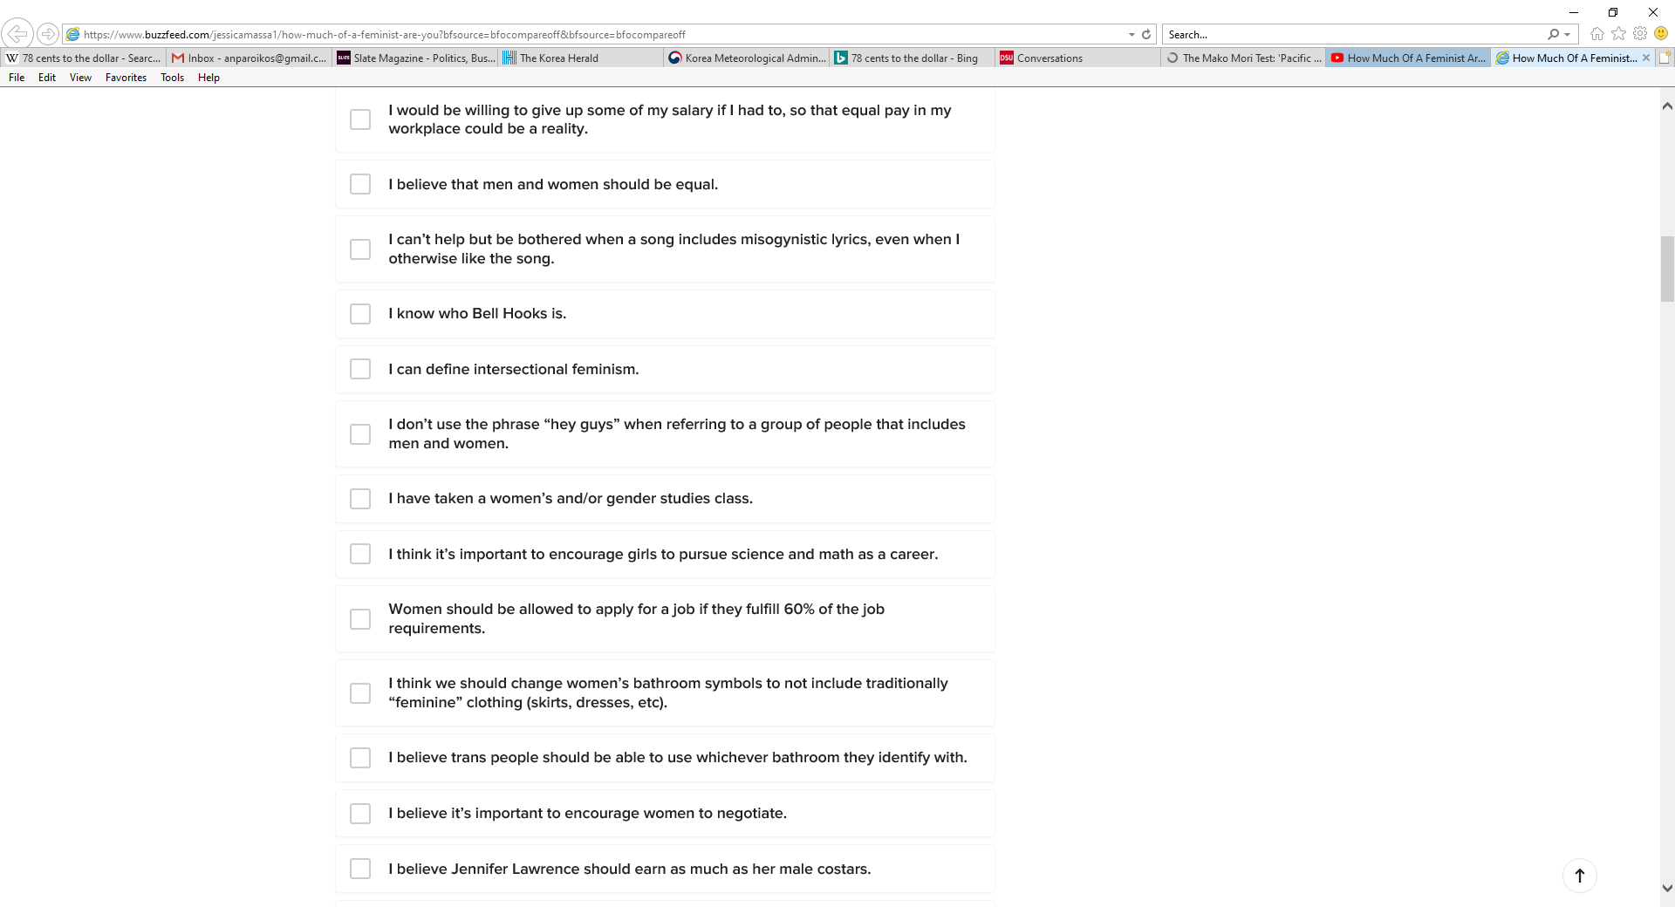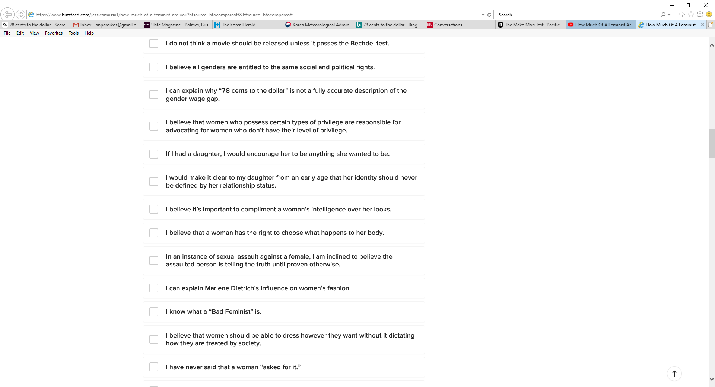 Take this rather subjective test to see how much of a feminist you are. Actually, no, this test isn’t the final word on whether or not you’re a feminist. However, it’s something you can learn from regardless of the result. Check all of the boxes you generally agree with, replacing any reference to the U.S. with that of your own country. Some vocabulary terms (not technical terms – either you know them, or you don’t!) are listed on the other side of the page. Go!

**List II**

**List 1**

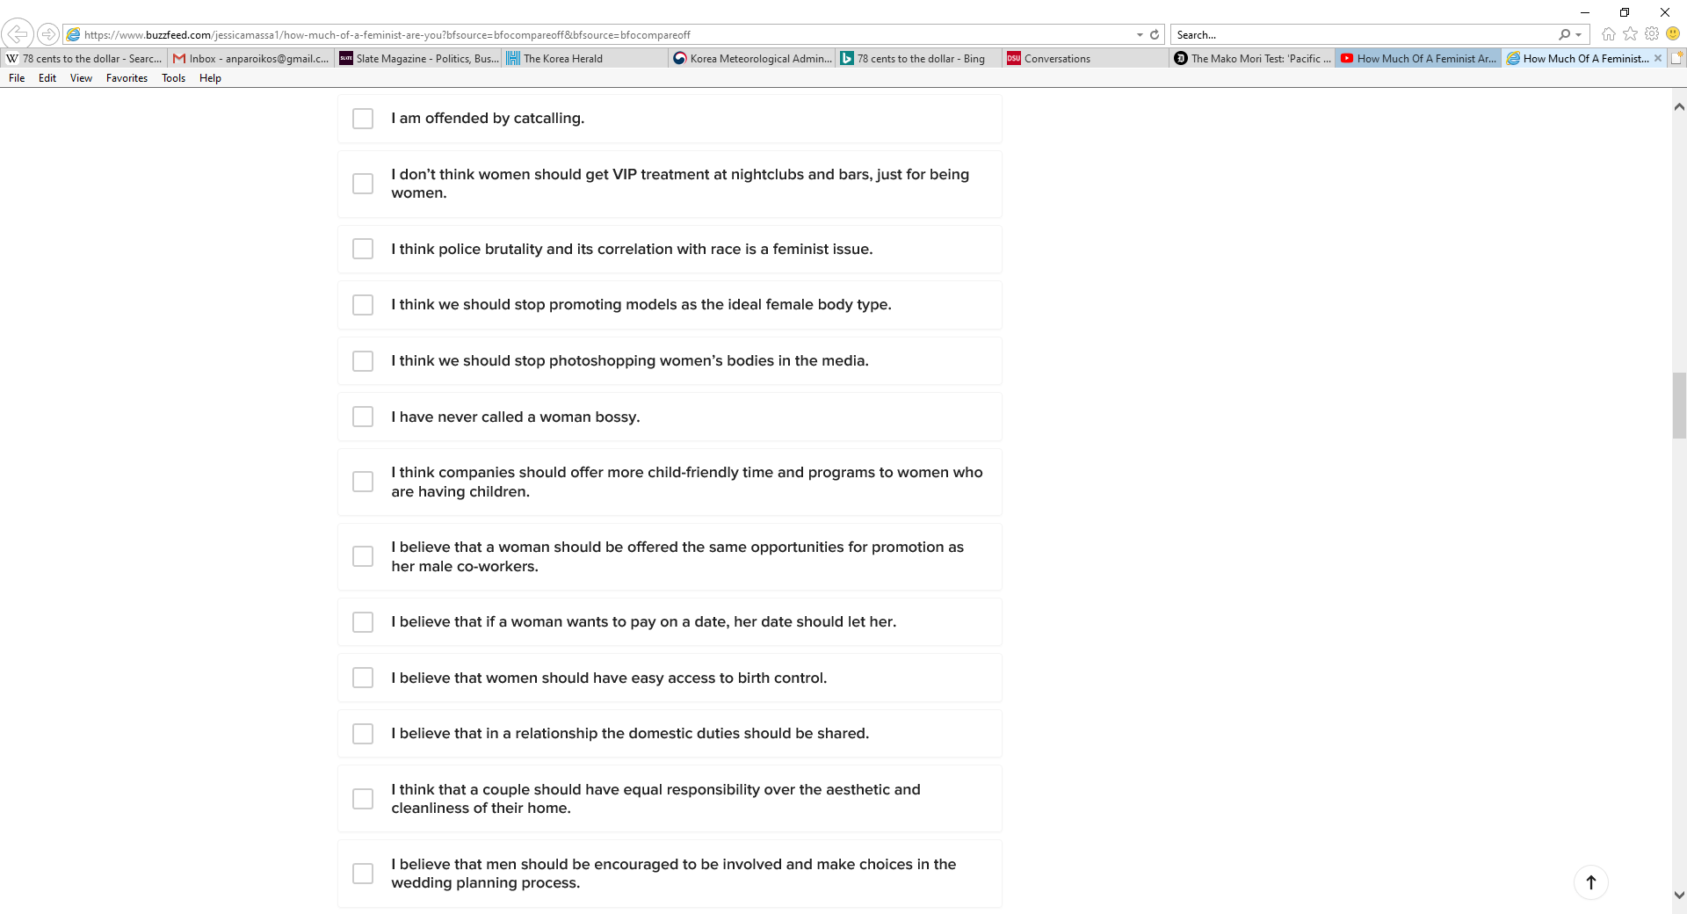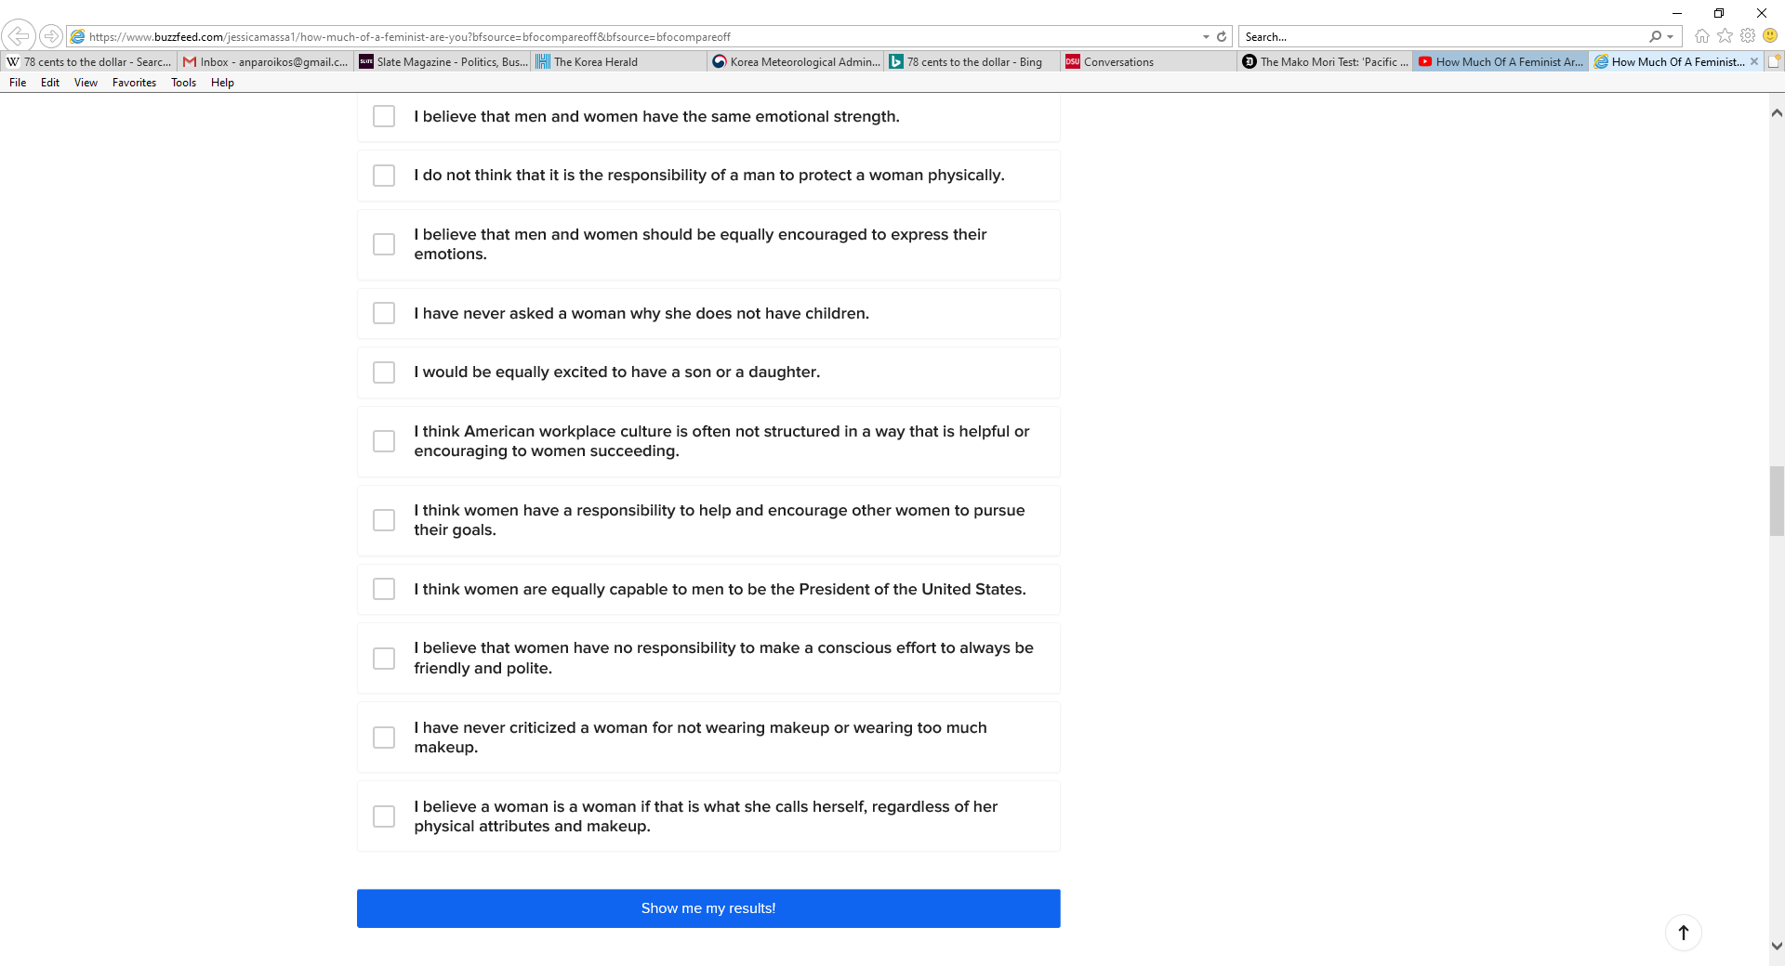

**List** 四

**List C**

This activity except for test copyright 2021 – Nelson Parish

Feminist test from <https://www.buzzfeed.com/jessicamassa1/how-much-of-a-feminist-are-you?bfsource=bfocompareoff&bfsource=bfocompareoff>

**Vocabulary for “How Much of a Feminist Are You?”**

**List 1**

“…can’t help but be bothered” (v. phrase) – automatically feel upset or annoyed

misogynistic (adj.) – showing disrespect towards females

lyrics (n.) – the words in a song or, sometimes, a poem

gender studies class (n.) – a university course that looks at how men, women, homosexuals, and/or transgender people view themselves and are viewed by society.

pursue (v.) – follow; participate in

fulfill (v.) – reach a level of ability, skill, experience, etc.; qualify for

trans person (n.) – someone who doesn’t identify with the physical sex society has marked them with (i.e., the person’s gender is different from their sex)

**List II**

be entitled to (v. phrase) – deserve

gender (n.) – one’s idea of whether one is masculine (male) or feminine (female) regardless of physical sex

wage gap (n.) – the differences in the average amount of money earned by two different groups

possess (v.) - have

privilege (n.) – advantage that a certain type of person has

advocate (v.) – argue for; ambitiously support

relationship status (n.) – an indicator of whether one is single, married, dating, etc.

sexual assault (n.) – rape, groping, and other behaviors done due to the sex or gender of the victim

dictating(adj.) – controlling; forcing

…a woman “asked for it” (expression) – an innocent woman is to blame for something bad that someone did to her

**List C**

catcalling (n.) – yelling sexual things in public to a person you don’t know (“Hey baby! Nice legs!”)

VIP treatment (n.) – special benefits given to people who are considered better than all or most others

police brutality (n.) – law enforcement officers being too violent with citizens

correlation (n.) – a seeming connection between two things

promote (v.) – uphold; advertise

Photoshop (v.) – use computer graphics to change an image, sometimes drastically

bossy (adj.) – apt to tell people what to do even though it’s not your job to do so

promotion (n.) – a move up to a higher level in one’s job

domestic duties (n.) – tasks in the household – cooking, cleaning, childcare, etc.

aesthetics (n.) – appearance (esp., related to beauty)

**List** 四

emotional strength (n.) – the ability of someone to handle the stress of daily life and recover from sudden stressful situations

physical attribute (n.) – what someone’s body (or part of it) looks or seems like

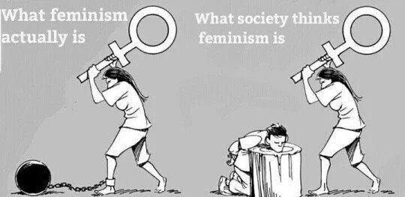...

**Questions for “How Much of a Feminist Are You?”**

1. Count the number of boxes in the survey that you checked. Divide that number by 50 to get your “grade.” For example, 50/50 = 100% (A+), 4/50 = 80% (B), etc. Are you surprised by your score? Why or why not?

2. English teacher alert! Some of the items are worded strangely. Some are vague (List 1 - “I would be willing to give up some of my salary...” How much? 1%? 50%?). Others are too extreme (List 四 - “…make a conscious effort to always be friendly and polite.”) Which ones would you change to make the survey better? How would you change them, and why?

3. Are there any other questions you think should be included on the survey?

4. This survey is from an American (progressive) viewpoint. Do any of the items seem progressive in your country? Conservative? Why?

This activity copyright 2021 – Nelson Parish

Feminist cartoon: https://jtristan.tistory.com/362

**The Video**

Now that you’ve answered the survey and discussed the questions with your partner(s), let’s watch a video in which six people – three women and three men – take the test. Look at the vocabulary below first.

|  |  |
| --- | --- |
| **Term** | **Definition** |
| 1. be a part of the conversation (v. phrase) | a. 14 advise someone in private, as a mentor would do |
| 2. confident (adj.) | b. 1 be involved in trying to solve a problem |
| 3. desensitized (adj.) | c. 7 closely related; combined in a complex way |
| 4. guys and gals (expression) | d. 341 flexibility |
| 5. highjacked (adj.) | e. 8 invasive; not invited or wanted |
| 6. “hot” word (n.) | f. 11 the male domination of a society |
| 7. intertwined (adj.) | g. 4 men and women; boys and girls |
| 8. intrusive (adj.) | h. 9 metaphorically, something someone thinks about all the time and is a huge part of their lifestyle |
| 9. lifeblood (n.) | i 5 metaphorically, stolen by an enemy |
| 10. not the president of the club (expression) | j. 3 not affected by; used to |
| 11. patriarchy (n.) | k. 2 self-assured |
| 12. perspective (n.) | l. 13 slang for make someone angry |
| 13. piss someone off (v. phrase) | m. 6 something (an expression) that is controversial |
| 14. take someone aside (v. phrase) | n. 16 something you ask so you can fool someone |
| 15. tense (adj.) | o. 10 somewhat, but not very, supportive of |
| 16. trick question (n.) | p. 15 stressed; worried; anxious |
| 17. unequal playing field (n.) | q. 17 unfair situation wherein one party has been given fewer advantages |
| 341. wiggle room (n.) | r. 12 viewpoint; opinion(s) |

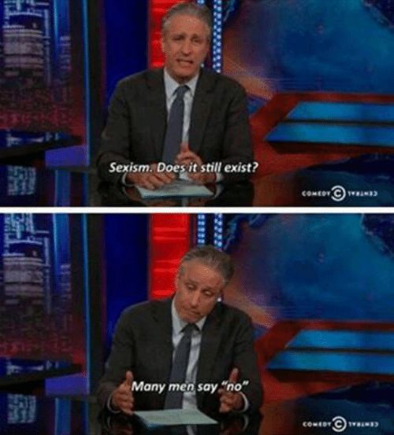. Next, answer these questions:

1. Who got the highest score? Who got the lowest? Were you surprised at the results?

2. How does the person with the highest score feel about their partner’s score? How does their partner feel?

3. How does the person with the lowest score explain why they got that score?

4. Which participants do you think are satisfied with their scores? Why do you think so?

You can watch the video for yourself at <https://www.youtube.com/watch?v=L3-YOOYOxEw>. You can take the test again at <https://www.buzzfeed.com/jessicamassa1/how-much-of-a-feminist-are-you?bfsource=bfocompareoff&bfsource=bfocompareoff>.

This activity copyright 2021 – Nelson Parish

Jon Stewart: https://nl.pinterest.com/pin/578642252094686478/